**1000010 from base 2 to base 10:**

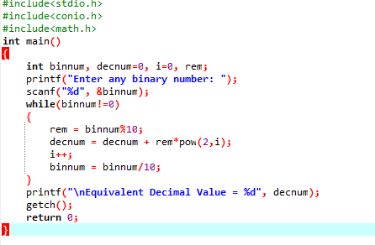

**Output:**

